**Bugs Reported**

**Defect #1:**

Description: Buggy Ratings Link is broken from inside the Popular Make page

**Steps to reproduce:**

1. Launch the Buggy Car Rating app.

2. Click on Popular Make card on the login page. User is routed to Popular Make page.

3. Click on the “Buggy Cars Ratings” link at the top left of the page. Verify that link is unclickable.

**Priority:** High

**Expected**: Navigate back to the login page.

**Actual:** Links is unclickable.

Upon inspecting the link it can be seen that it has a href as /broken:

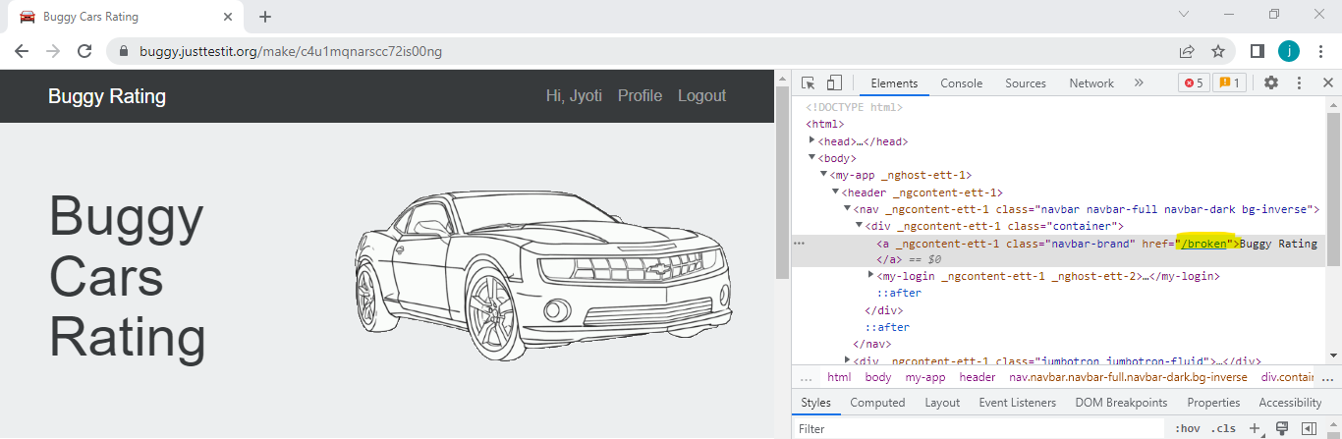

**Defect #2:**

**Description:** Profile page is retained when logout is clicked from inside the Profile page

**Steps to reproduce:**

1. Launch Buggy Car Rating app.
2. Login a valid user and go to Profile page.
3. Once inside the profile page, click logout from top right corner.
4. Notice that user is logged out but Profile page is still retained in the bottom half of the page exposing confidential user detail.
5. Change some information on profile page and click save. We should see an error in network tab saying unauthorized.

**Priority:** Critical

**Expected**: Navigate back to the login page.

**Actual:** User stays on Profile page.

**Note:** This bug also applies to logout from Popular Make and Popular Model pages as well

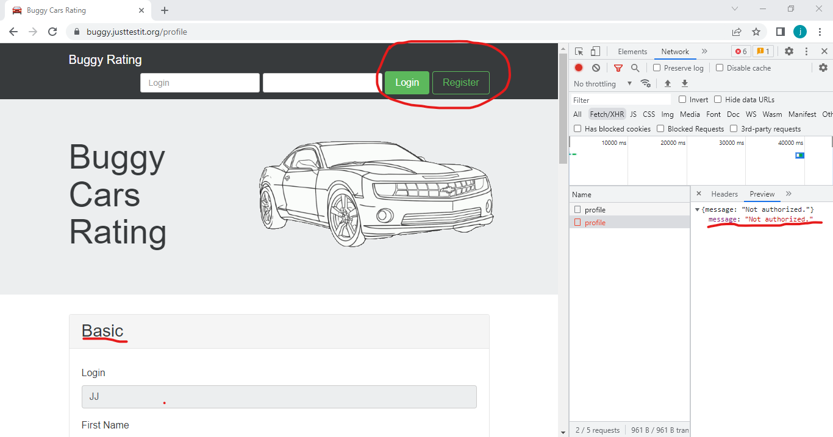

**Defect #3:**

**Description:** Logout link is broken from inside the Overall rating page

**Steps to reproduce:**

1. Launch the Buggy Car Rating app.

2. Login with a valid user.

2. Click on Overall Rating card on the home page. User is routed to Overall Rating page.

3. Click on the “Logout" link at the top right of the page. Verify that link is unclickable.

**Priority:** High

**Expected**: User should be logged out and navigated back to home page.

**Actual:** Link is unclickable.

Upon inspecting the link it can be seen that it has a href as javascript:void(0):

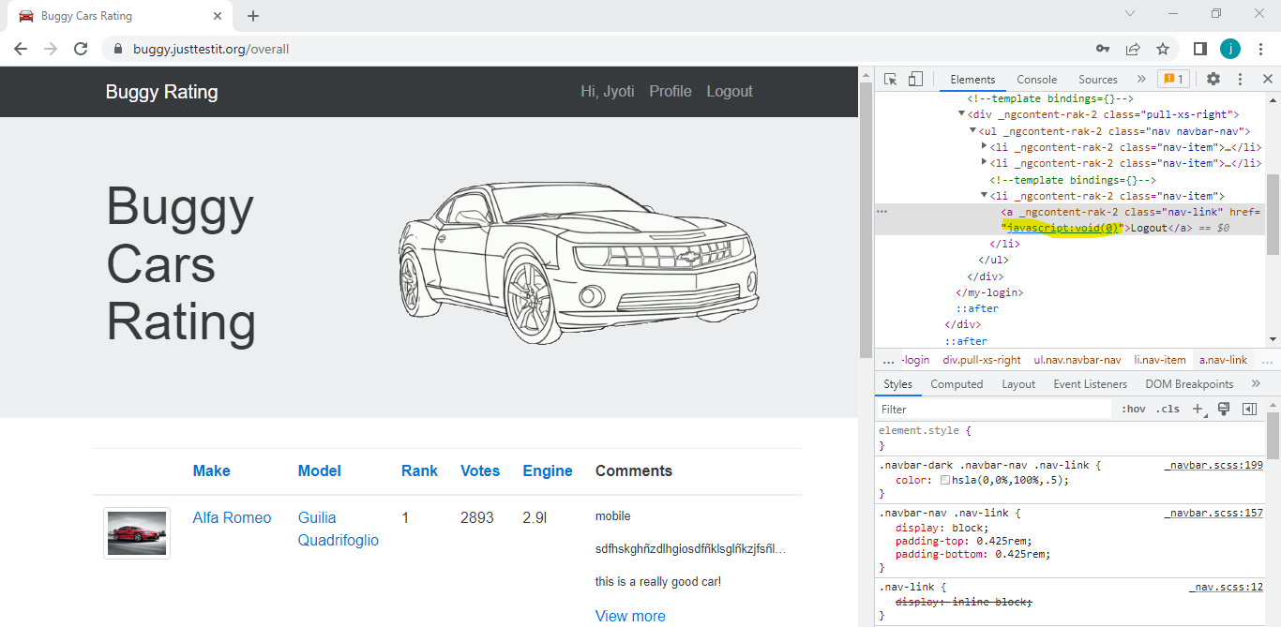

**Defect #4:**

**Description:** Broken twitter link on Overall Ratings page

**Steps to reproduce:**

1. Launch the Buggy Car Rating app.

2. Click on Overall Rating card on the login page. User is routed to Overall Rating page.

3. Click on twitter icon on the bottom right of the page. Verify that link is broken and a broken page opens in a new tab.

**Priority:** Medium

**Expected**: Twitter page should open

**Actual:** User is routed to a broken page - <https://www.twitter-broken.com/>

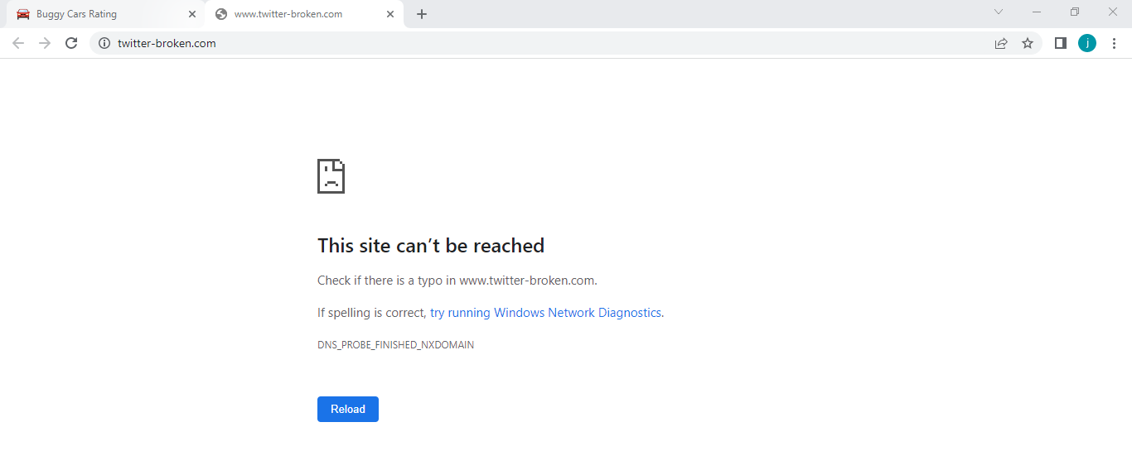

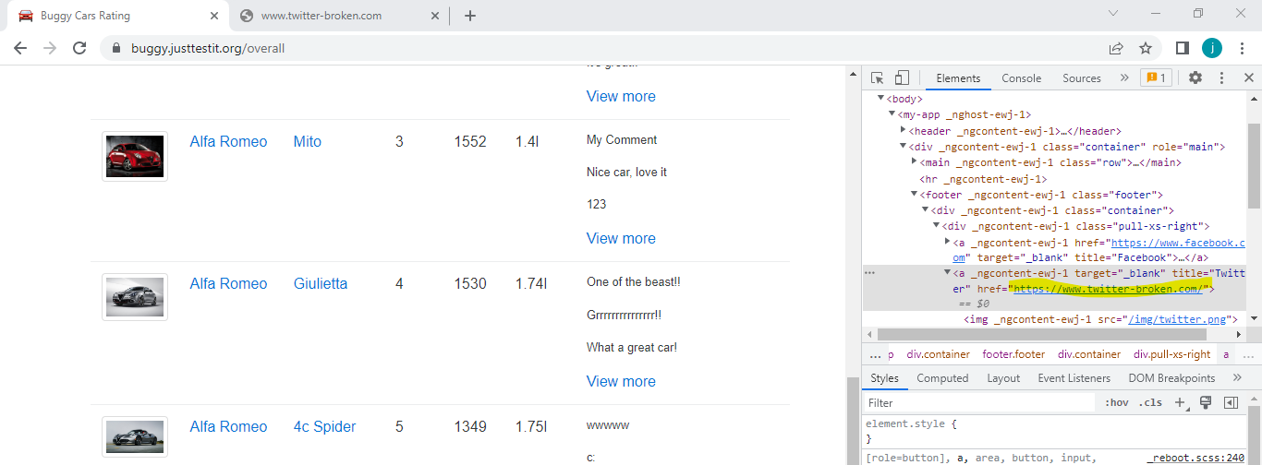

**Defect #5:**

**Description:** Pagination on Overall Ratings page show 5 pages but we can actually go to a sixth blank page

**Steps to reproduce:**

1. Launch the Buggy Car Rating app.

2. Click on Overall Rating card on the login page. User is routed to Overall Rating page.

3. Click next on the pagination at the bottom right of the page until we reach page 6 of 5.

**Priority:** Medium

**Expected**: We should not be able to go to page 6.

**Actual:** We can see page 6 of 5 and page 6 is a blank page.

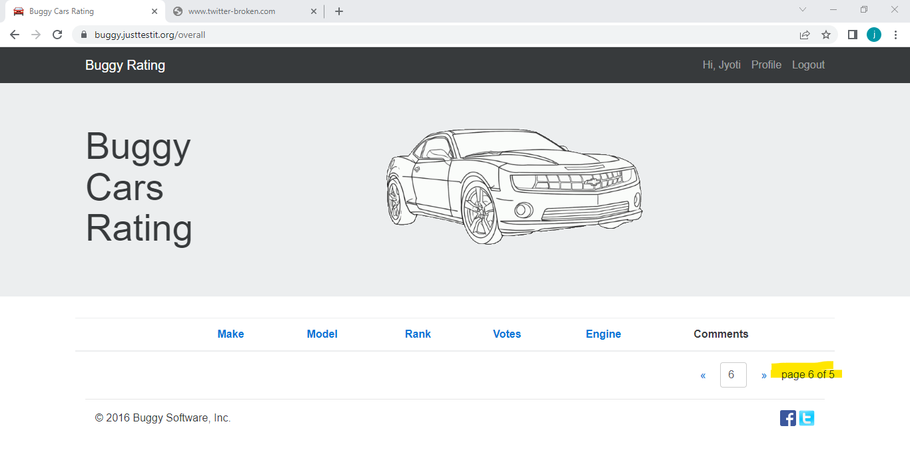

**Defect #6:**

**Description:** Author not populated in the table when user comments on a car model

**Steps to reproduce:**

1. Launch the Buggy Car Rating app.

2. Click on Overall Rating card on the login page. User is routed to Overall Rating page.

3. Click on View more for Alpha Romeo Mito.

4. Add a comment and click vote.

5. Verify that author name is not reflected in the table.

**Priority:** Medium

**Expected**: Date, Author and Comment should be populated in the table

**Actual:** Author field is blank

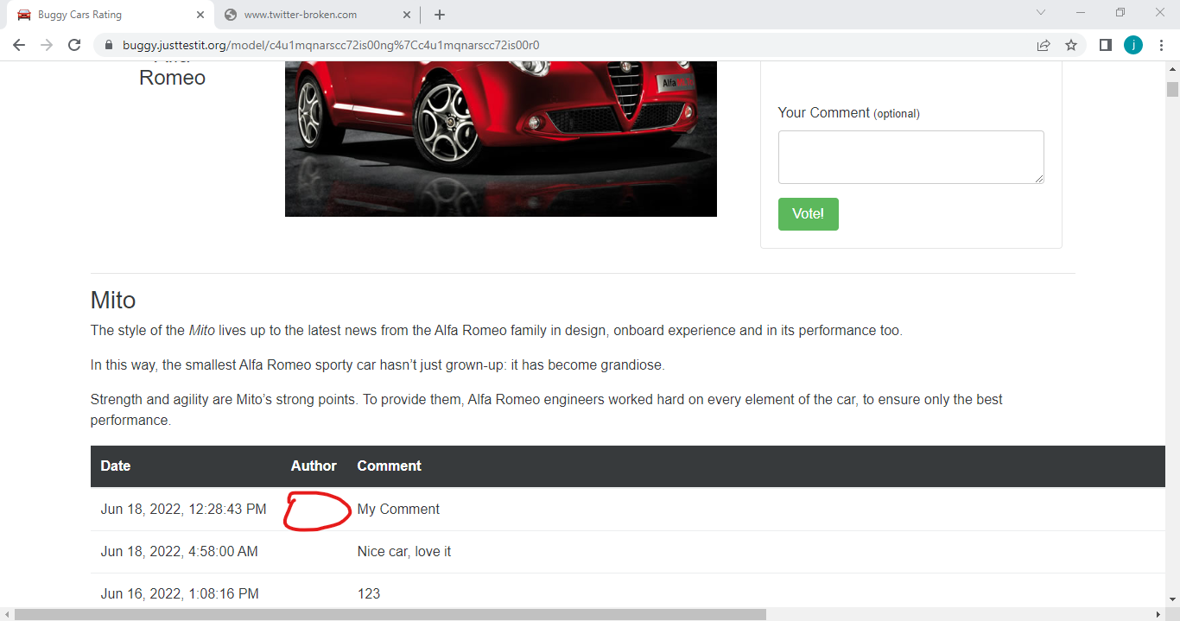

**Defect #7**

**Description:** Gender field in Profile page is implemented as a input field instead of a select drop down list

**Steps to reproduce:**

1. Launch the Buggy Car Rating app.

2. Login to app and go to profile page.

3. Try clicking on the dropdown arrow of the gender field. User is not able to click it.

4. Enter any value other than “Male” or “Female” in the field and click save.

5. Verify that user is able to save it without any issues.

**Priority:** High

**Expected**: Gender field should not allow invalid values.

**Actual:** User is able to save any value in the gender field.

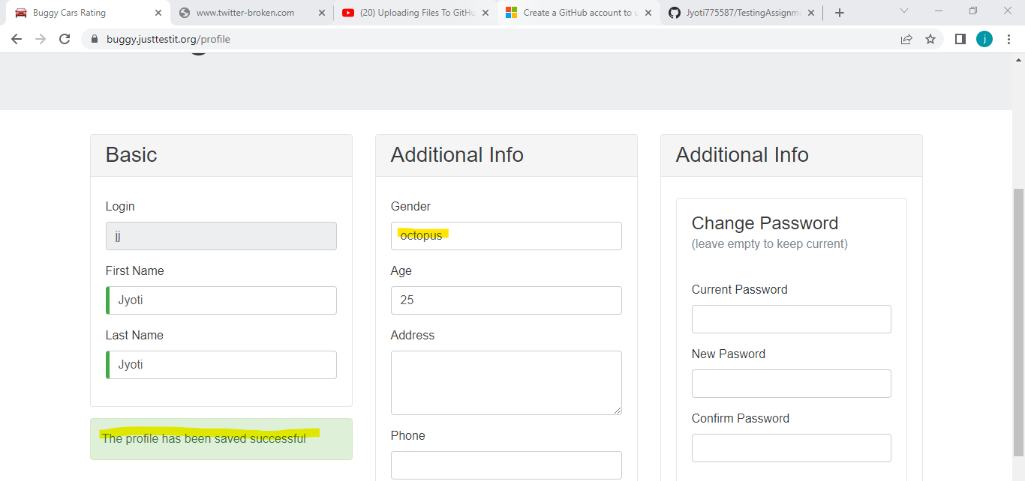

**Defect #8**

**Description:** Incorrect validation error for Last Name field on Profile page

**Steps to reproduce:**

1. Launch the Buggy Car Rating app.

2. Click on Register link.

3. Enter some text in last name field and clear the field.

4. Verify that incorrect validation error appears below the field.

**Priority:** Medium

**Expected**: "Last Name is required” validation error should appear

**Actual:** "First Name is required” validation error appears

